Conversations about Assignment 2 Web Programming with Team Members.

All screenshots were taken on August 5, 2023. Read from left to right, top to bottom.

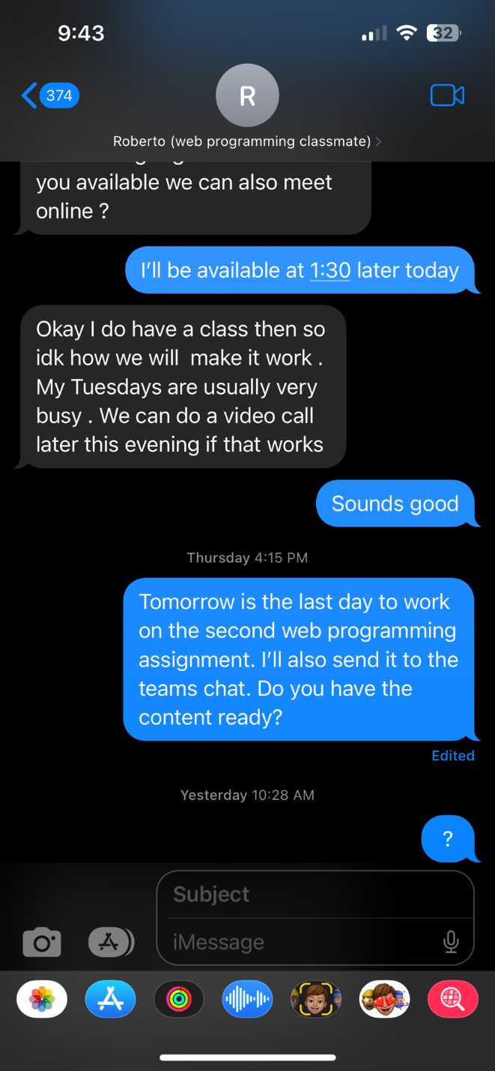

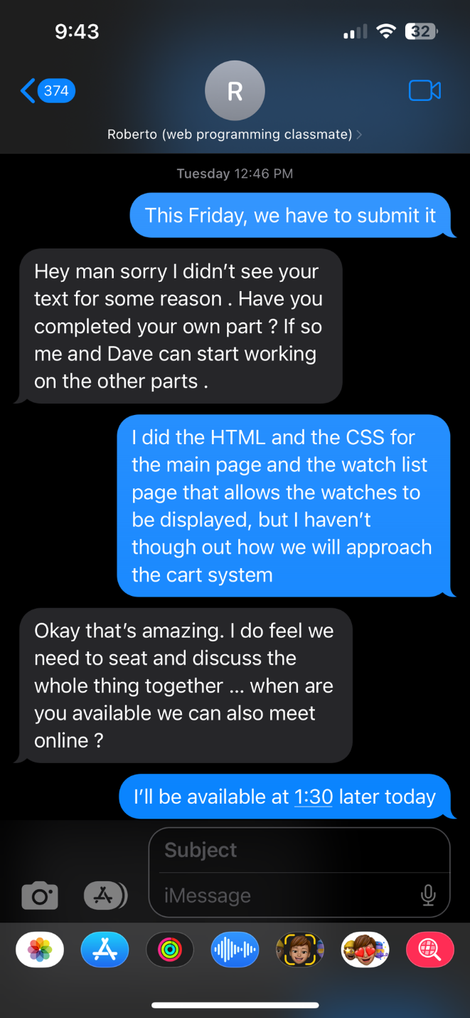

We didn’t do a video call that day

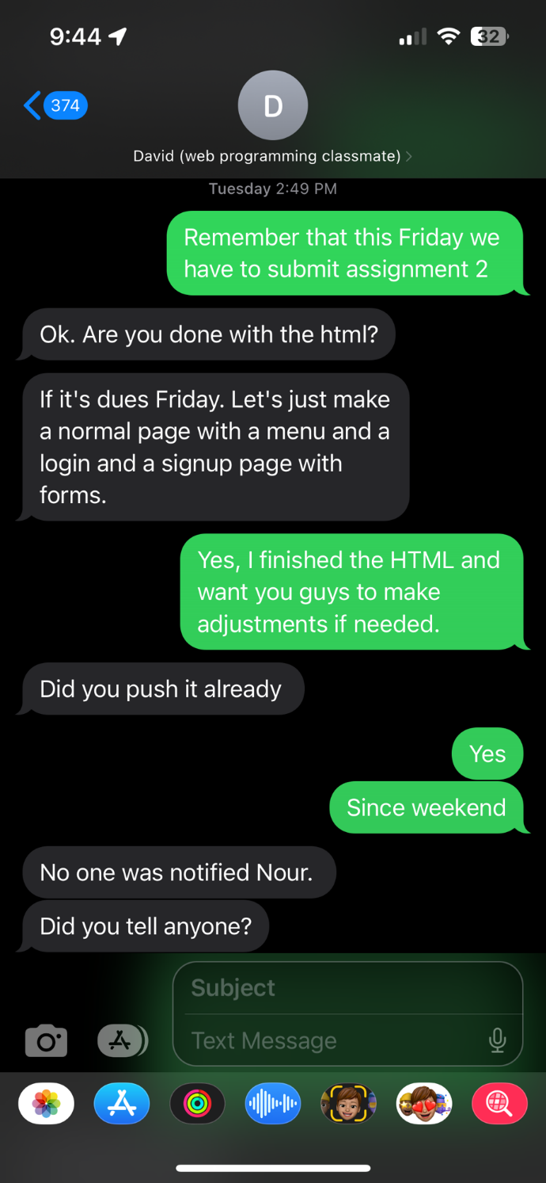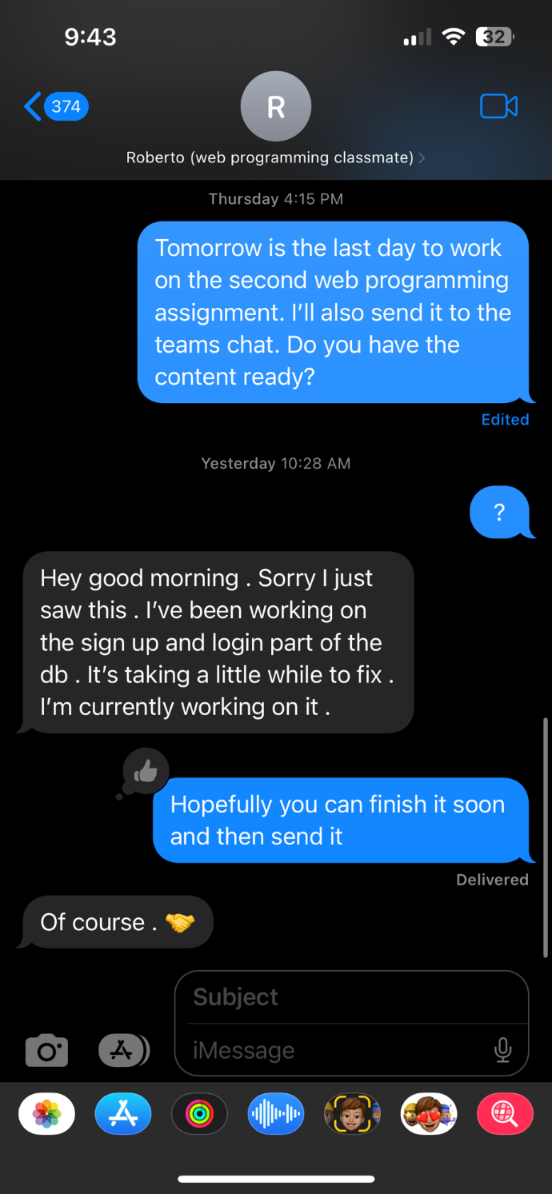

I never received anything after that

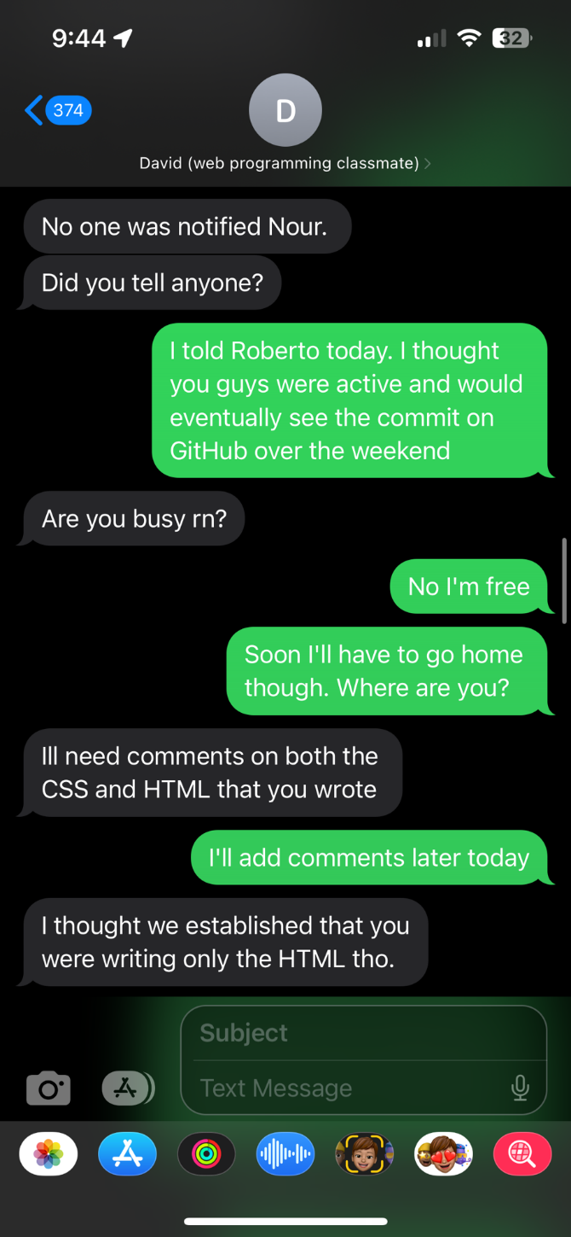

He did not come to meet me that day.

He did not make any arrangements to

meet after

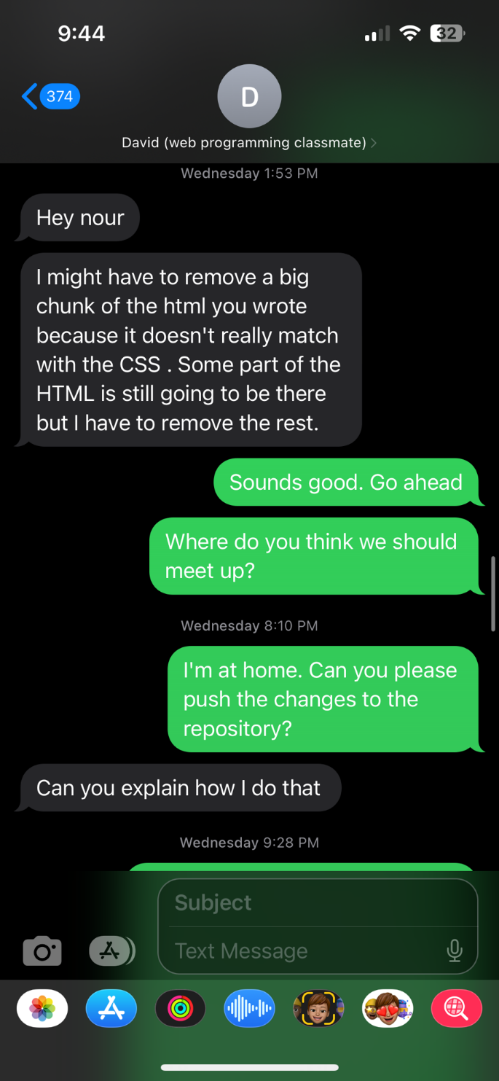We did not meet up after my second request

to arrange a meeting.

Nothing was pushed to the repository

Even after explaining the steps to do so.

See git commit history image below.

I sent all of the instructions to David on how

to use GitHub for Desktop and upload his changes.  
 Nothing was pushed/submitted.

Instructions (images above and below) were sent on August 3, 2023, 4:04 PM. Recall due date was August 4, 2023.

